**Quiz # 4: Student ID: ________________ Date: 07/07/2019**

**___________________________________________________________________**

1. **Consider following knapsack problem; A bag of total capacity 15kg; You have to select from different items as given in table, so that you gain maximum profit using genetic algorithm. Must specify the structure of chromosomes? What will fitness function (Clearly Explain)? How you will perform mutation and cross over? Give example.**

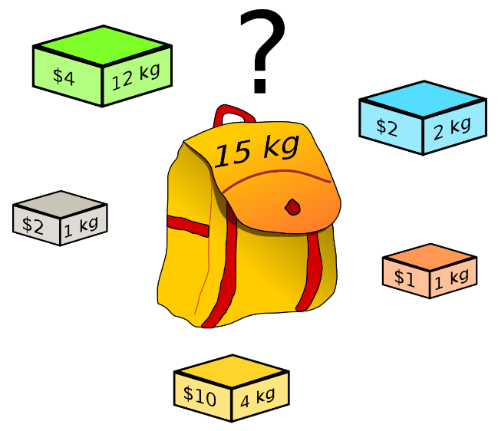

|  |  |  |
| --- | --- | --- |
| Item Name | Item Weight | Item Value/Price |
| A | 12 kg | $4 |
| B | 2 kg | $2 |
| C | 1 kg | $2 |
| D | 4 kg | $10 |
| E | 1 kg | $1 |